Intake Nutritional Form

Precision Pet Nutrition

Pet(s) Name ____________________________________

Breed: ________________________________ M F Pet’s weight _______________

Age ______ DOB _______________ Appropriate weight for breed ________

Current Medical Issues :____________________________________ Vet Notes: Y N

___________________________________________________

Current Vet:

___________________________________________________

___________________________________________________

__________________________________________________ Last Vet Visit ? _______

Home Cooked or Commercial __________________________________________________

Current Medications:___________________________________________________________

Current Diet : ____________________________________________________________________

Amount : ______________________________ How many times a day and time.

Treats : How often ______________________________________________________________

Any previous prescription Diet ? __________________________________________________

______________________________________________________________________________

______________________________________________________________________________

Current protein: beef pork chicken venison lamb goat turkey duck

Other __________________________________________________________

Favorite food flavors : ______________________________________________________

Known allergies : ____________________________________________________________________________________________________________________________________________________________

Supplements ? ___________________________________________________________________

______________________________________________________________________________

Water ? Filtered Bottled Tap

What problems is your pet experiencing? *

 Poop eater  Dark or smelly stools  Irregular stools  “Greasy” stool  Excessive gas

 Excessive water intake Vomiting or Diarrhea  Bad Breath

 Tartar buildup  Dry elbows (callouses)  Open sores or hot spots

 Excessive licking or chewing of the feet  Anal gland issues (butt scooting)

 Weepy/red staining eyes  Ear issues/excessive buildup/scratching  Biting at tail

 Excessive shedding  Lethargy/lack of energy Joint/Mobility Issues

 Hair loss

 Other (explain below) __________________________________________________________________________________________________________________________________________________________________________________________________________________________________________________________________________________________________________________________________________________________________________________________________________________________

Any other problems? ______________________________________________________________________________________________________________________________________________________________________________________________________________________________________________________

Do you use any parasitic? Topical or oral?

 Seresto  Frontline  Frontline Plus  Advantage  K9 Advantix  Biospot

 Heartguard Plus  Trifexis  Revolution Interceptor Plus  Simparica Trio  Sentinel

 Tri-Heart Plus  Ivermectin  Any tick collar

 Other __________________________________________________

Up to date current vaccination? Vaccination record ?

Pet’s activity level ? None ( couch potato unless someone’s in the kitchen?)

Moderate : Nice regular walks play time in the dog park or yard.

Active : Agility training; Working dog. At least 1 hour of activity daily

What activities Does your dog do regularly

______________________________________________________________________________________________________________________________________________________________________________________________________________________________________________________________________________________________________________________________________________________________________________________________________

Does the dig get the “zoomies” ? ____________________________________

Recent diet changes ____________________________________________________________________________________________________________________________________________________________

Any noticeable changes Changes: __________________________________________________

Recent behavioral changes? Y N

Urinating: more less

Defecation changes Y N _______________________________________________________

Appetite ________________________________________________________________________

Activity _________________________________________________________________________

**Please describe your feeding philosophy and goals with home-prepared food for your dog. For example, do you want to feed it all the time? 50% with commercial food? Do you have a strong preference for or against raw or cooked, or grains or grain-free? ___________________________________________________________________________________________________________________________________________________________________________________________________________________________________________________________________________________________________________________________________________________________________________________________________________________________________________________**

Current diets: Please list the product names, flavors and amounts of all foods, treats, chews, and anything else your pet is currently eating. Include enough detail so that we could go to the store and purchase the exact same food. Include “people foods” given as treats or as part of a homemade diet.

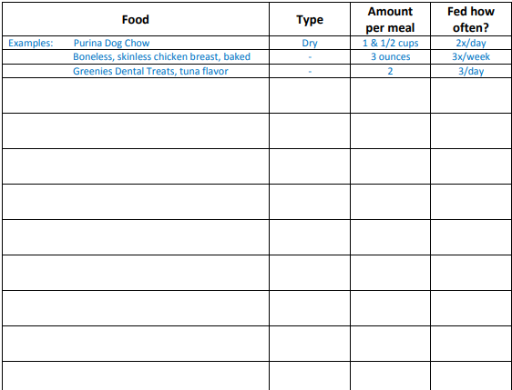

Consent :

I ____________________________________, allow Stacey Jablin to use any information I provided to evaluate the health and nutritional needs of my pet(s). I understand that Mrs. Stacey Jablin is not a veterinarian, nor does she claim to be. Stacey Jablin is a certified canine nutritionists. Stacey has experience in animal health based on proper nutrition, exercise and healthy supplementation. We are not liable for any outcomes, promised or implied. We always encourage you to seek the advice of a trusted veterinarian.

______________________________________________________________________________

Client Signature Date